PAPER ONE
READING AND WRITING
(1 hour 10 minutes)

PART 1
QUESTION 1-5
Which notice (A-H) says this (1-5)?
For the questions 1-5, choose the correct option (A-H).

EXAMPLE ANSWER
0 We are only open in the morning. G
SWIMMING POOL
ADULTS ONLY 6-8 P.M.

1 | Not all drivers can stop here. D |  |  | A  TELEPHONE for customers’ use only
2 | Children cannot come here in the evening. A |  |  | B  DANGER  No Traffic Lights Ahead  C
3 | Drivers must be careful. C  Careful=danger |  |  | PARKING FOR POLICE CARS ONLY  D  LEEDS CASTLE  FREE ADMISSION FOR CHILDREN
4 | Not everyone can make a call from here. B  Not everyone = only  Not all = only |  |  | E  Film matinee 2 p.m. £ 3.00
5 | Only adults have to pay here. E |  |  | F
 |  |  |  | Bookshop – Closed afternoons
 |  |  |  | G
 |  |  |  | TELEPHONES ON SECOND FLOOR
1. …D…….. |  | 2. ……A….. | H  3. ……C….. |  |  | 4. …B….. | 5. ……E……..

PART 2 –
QUESTIONS 6 – 10
Read the sentences about sport. Choose the best word (A, B or C) for each space.
6. They both play volleyball very ………………
A better B well C far
7. They decided to ……………… a volleyball club last month.
A join B add C go
8. The team ……………… one evening a week for training.
A looks B sees C meets
9. Amy and Kazu have already ……………… lots of friends at the club.
A done B made C taken
Make friends: ket ban
10. They ……………… to play in a match soon.
A feel B think C hope

PART 3
QUESTIONS 11-15
Complete the five conversations. For questions 11-15, mark A, B or C on the answer sheet

11 Let’s walk to the park. | A All right.  B I think so.  C I’m sorry.
12 When did you arrive? | A Tomorrow.  B Yesterday.  C For two days.
13 Shall I open the window? | A Yes, I shall.  B Yes, you will.  C Yes, please.
14 I got a letter from Paul this morning. | A I’m afraid not.  B That’s nice.  C He’s fine.
15 How’s your sister?  How +be +S? | A She’s Jane.  B She’s at school.  C She’s very well.

PART 3 -
QUESTIONS 16-20
Complete the conversation between two friends. What does Tina say to Adrian?
For questions 16-20, choose the most appropriate response (A-H) for your answer.
EXAMPLE | ANSWER
Adrian: Hello, Tina. How are you?  Tina: 0...................... | D

 | Adrian: I’m fine. Did you have a good holiday in Florida?  Tina: 16 E  Adrian: Really? Perhaps I should go there. Was it very expensive?  Tina: 17. C  Adrian: I heard that they have very good fish there.  Tina: 18 A  Adrian: And did you visit any cities?  Tina: 19 G  Adrian: Are they? I don’t like swimming very much. Didn’t you go to Disneyland?  Tina: 20 H  Adrian: Yes, you’re right. |  |  | A. Yes, that’s right. But the other things are good too.  B. Yes, that’s true. But I enjoyed it anyway.  C. Well, I paid a quite lot for the flight, but the food was very cheap.  D. Adrian! I’m very well thanks. What about you?  E. I had a wonderful time. I’m going back again next year.  F. I did. But the meat is very good too.  G. Not many. I spent most of the time on the beach because the water sports are excellent.  H. Oh yes. It’s wonderful. But there are lots of other places to visit in Florida too.
16. …E |  | 17. …C | 18. …A | 19.…G. | 20. H.

PART 4

QUESTIONS 21-27

Read the article about Esther and then answer the questions. For questions 21-27, mark A, B, or C on the answer sheet.

ESTHER’S STORY
When Esther left school at the age of sixteen, her aunt Flory gave her £500 for her birthday. Most of Esther's friends decided to go to college, but Esther used her aunt's money to start her own business. She bought fruit, sugar and some glass jars and began making her own jam. She sold the jam for £1 a jar to her friends and she soon doubled her aunt's £500.
At first, her parents didn't want Esther to spend her time making jam and they thought that she should study instead. They hoped that one day she would be a teacher or a doctor. But Esther didn't listen to them. She just kept on making jam. After a few months, she started selling it to the local market. Then she started making orange juice. She sold this to a school where one of her friends worked.
After two years, her business was very large, and her parents were very pleased with her. She made all kinds of food which she sold to shops and supermarkets. She was so busy that she had to get some people to work for her.

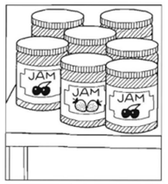

21. Why did Aunt Flory give Esther some money?
A. Esther asked for it. B. Esther’s friends needed it. C. It was a present.
22. After she left school, Esther
A. went to college | B. started her own business | C. worked for her aunt
23. Why did Esther make jam?
A. She liked to eat it. | B. She had a lot of fruit. | C She wanted to make money.
24. When Esther left school, her parents wanted her to
A. go to college | B. be a businesswoman | C. work in a market
25. Esther sold orange juice to
A. the local market. | B. a school. | C. her friends.
26. Esther’s parents were happy because Esther
A. cooked for them. | B. was busy. | C. had a good business
27. After two years, Esther
A. paid people to help her | B.worked in a supermarket | C. opened a shop

PART 5
QUESTIONS 28-35
Read the article about bicycles.
For questions 28-35, choose the best word for each space.
BICYCLES
The bicycle is ……0… cheap and clean way to travel . The first bicycle ………28……… made about one hundred and fifty years ago.
At first, bicycles were expensive. Only rich people ………29………. buy one. These early bicycles looked very different from the ones we have today. Later, ……30…….. bicycles became cheaper, many people ………31……… one. People started riding bicycles to work and in ………32…….. free time .
Today, people use cars more than bicycles; cars are much …………33…….. and you don't get wet when it rains! But some people ………34……… prefer to cycle to work . They say that ………35……… are too many cars in town centres and you can't find anywhere to park.
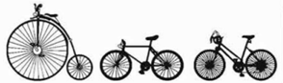

EXAMPLE |  |  |  | ANSWER
0. | A. some | B. any | C. a | C

28. A. was B. is C. were
29. A. must B. could C. may
30. A. when B. if C. that
31. A. buy B. buys C. bought
32. A. their B. his C. its
33. A. fast B. faster C. fastest
34. A. yet B. still C. already
35. A. they B. there C. here

PART 6

QUESTIONS 36 – 40

Read the descriptions (36-40) of some people in a family. What is the word for each description? The first letter is already there. There is one space for each other letter in the word. Write the correct word in the box.

EXAMPLE ANSWER

0. If your child is a boy, he is this. s o n

- This is your mother’s brother.  - She is your father’s mother.  - This is the person a man is married to.  - This is your father’s sister.  - If your child is a girl, she is this. | u n c l e  g randmother  w ife  a unt  d aughter

PART 7 –
ESTIONS 41-50
Complete these letters. Write ONE word for each space.

Dear Mrs. Robinson,  I am (0) ....... (Example:…sorry…) I wasn’t in your lesson yesterday. I fell off my bicycle (41) ............ the morning so I could (42) …......get to school. The doctor told (43) .......... that I must stay (44) ............ home today. Luckily, I (45) ............ not broken anything. I’m sure I (46) ............ be back tomorrow. What was yesterday’s homework?  Yours,  Karl |  | Dear Karl,  What (47) ............ pity about your accident. How (48) ............ you fall off your bicycle? (49) ...........wasn’t any homework yesterday because we (50) ............ to York on a school trip.  Best wishes,  J Robinson

41 in | 42. not | 43. me | 44. at | 45. have
46. will | 47. a | 48. did | 49. There | 50. went

PART 8
QUESTIONS 51-55
Read the information about language courses and the e-mail message.
Fill in the information on the Course Booking Form.
Write your correct answer in each box (51-55).
Language Courses
French: Monday evening
German: Thursday evening
Portuguese: Tuesday afternoon
Spanish: Wednesday evening

Afternoon classes: 2.30 - 4.30 p.m.
Evening classes: 6.30 – 8.30 p.m.
To: International Language School
I come from Australia, and I teach French to businessmen. I want to start learning Portuguese because next year I am going to work in Brazil. I am free after 1 p.m. on Tuesdays and Thursdays. Can I book a place on one of your courses?
Cheryl Harvey

International Language School
Course Booking Form
Full name:  Nationality: quoc tich  Occupation: =job  Name of course:  Day:  Starting time: | Cheryl Harvey
 | 51 | Australian
 | 52 | teacher
 | 53 | Portuguese
 | 54 | Tuesday
 | 55 | 2.30 p.m.
PART 9
You are Jack. You are going to have a party. Write a note to a friend Mike:
- Ask your friend to come.
- Say when and where the party is.
Dear Mike
I am going to have a birthday party. Would you like to come with me? The party start at 7.30pm this Saturday at my house. You don’t bring anything to my house. See you soon.
Love
Jack

NGHE
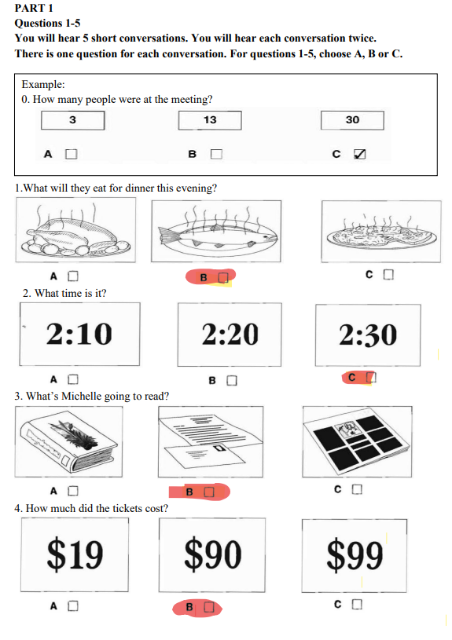
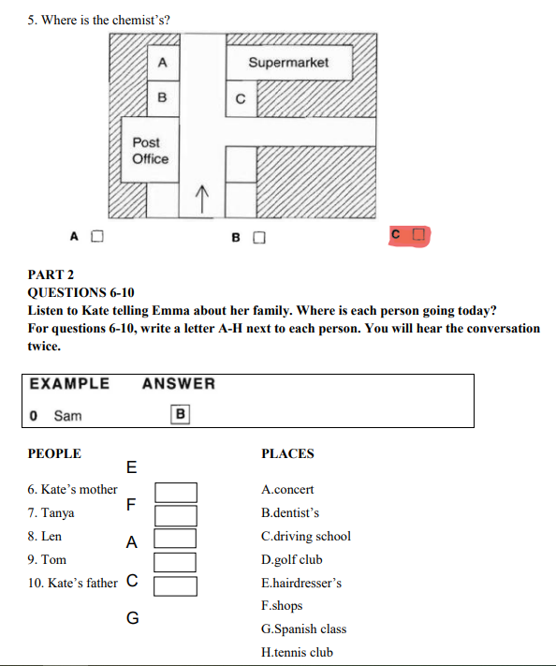
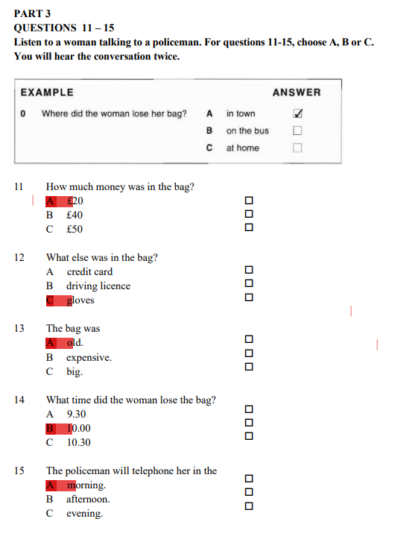
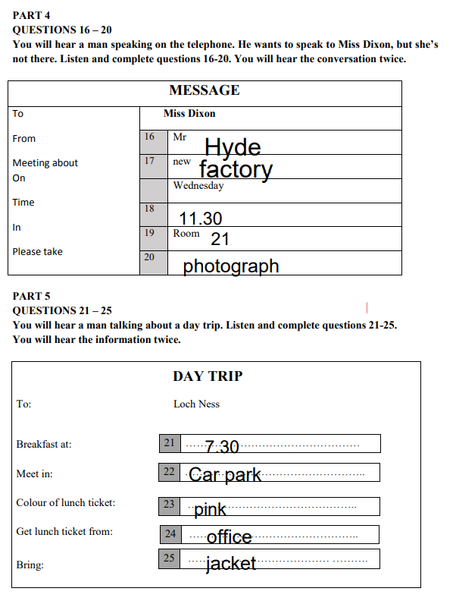

PART 1
QUESTION 1-5
Which notice (A-H) says this (1-5)?
For the questions 1-5, choose the correct option (A-H).
EXAMPLE ANSWER
0 You can leave your suitcase here. C
1 | You must drive carefully here. H  Careful/ carefully = danger |  |  | A | NO SERVICE STATION ON MOTORWAY  Travel Express  NEW BUSINESS HOURS  9 A.M. – 6 P.M.
2 | You can eat cheaply here. G  Cheap =low price |  |  | B  C | LEFT LUGGAGE  OPEN 24 HOURS
3 | You can stay here on holiday. E |  |  | D
4 | You can find work here. F |  |  | E | PLEASE USE OTHER DOOR  Campsite Open All year  JOB AGENCY  We've got the right job for you
5 | You must not go in this way. D  Way = door |  |  | F
 |  |  |  | G | Joe's Snack Bar  Lowest Prices in Town!
DANGER!
ICE ON ROAD
1. ……H.. |  | 2. …G….. | H  3. ……E….. |  |  | 4. ……F….. | 5. …D……..
PART 2
QUESTIONS 6 – 10
Read the sentences about a birthday. Choose the best word (A, B or C) for each space.
6. Nina was very .................... because she got lots of presents.
A. interesting | B. lovely | C. happy
7. She .....................some friends to her house for a party.
A. decided | B. agreed | C. invited
8. Her mother made a big chocolate ..................... with "Happy Birthday" on the top.
A. meal | B. cake | C. dish
9. Nina and her friends had a great time, singing and dancing and ..................... to their favourite music.
A. listening | B. hearing | C. looking
10. When they had to go, everybody ..................... Nina and her mother for the party.
A. said | B. thanked | C. told
PART 3.
QUESTIONS 11-15
Complete the five conversations. Choose the most appropriate response for your answer.

11 Hello, Sue. This is my boss, Mrs Smith. | A How old is she?  B How much is it?  C How do you do?
12 Tell Ben to come upstairs. | A That's right.  B All right.  C Is that right?
13 Have you got a ticket. | A At the ticket office.  B Here it is.  C Yes, please.
14 Let's go to Brighton tomorrow. | A What a pity!  B OK. Why not?  C It doesn't matter.
15 Can I open the window, please? | A You don't.  B It isn't.  C Of course.

QUESTIONS 16-20
Complete the telephone conversation. What does Peter say to James?
For questions 16-20, choose the most appropriate response (A-H) for your answer.
EXAMPLE | ANSWER
James: Hello, 345920  Peter: 0...................... | G

 | James : No, I don't think so. Why?  Peter : 16 E  James : Where are they playing?  Peter : 17 B  James : I'd love to come. How much are the tickets?  Peter : 18. A  James : Will we have to leave early.  Peter : 19 H  James : What time should we meet?  Peter : 20 C  James : Thanks, Peter. Goodbye.  Peter : Goodbye. |  |  | A. They're free. My father gave them to me.  B. In London. We can go on my car.  C. I'll call you again on Friday to arrange the time.  D. My car's very small.  E. I've got some tickets for the football – England against France.  F. We can meet in the town centre.  G. Hello, it's Peter. Are you busy on Saturday?  H. I suppose so. There may be a lot of traffic.
16. …E… |  | 17. …B… | 18. …A…… | 19. …H…. | 20. …C….

PART 4

QUESTIONS 21-27
The Long Night  This is David Reilly's first book. David became a writer after teaching English for several years.  Maha is a nurse in northern Australia, where she works in a small hospital. One day a baby is so ill that Maha has to drive all night to get her to the nearest big city. They have a lot problems getting there and… | Hard Work  This exciting story Joanna Jones's twentieth.  Hard Work is about Sombat, who works with his father, a carpenter, in Thailand. They work long, hard hours making tables and chairs, but they do not have any money. Then one day a man dressed in all black buys the most beautiful table in the shop… | Hospital or Cinema?  Marcie Jacome, who studies English in London, wrote this story earlier this year.  Tina is a young Brazilian woman whose dream is to become a doctor. She goes to London to study English and medicine but one day she meets a man who asks her to go to the USA with him to become a film star…What will Tina do?

EXAMPLE ANSWER
0. Which book is about somebody who works with doctors? A
A. The Long Night | B. Hard Work | C. Hospital or Cinema
2
1. Which book is by somebody who has written a lot of books?
A. The Long Night | B. Hard Work | C. Hospital or Cinema
22. Which book is about somebody who is very poor?
A. The Long Night | B. Hard Work | C. Hospital or Cinema
23. Which book is about somebody who would like to work in a hospital?
A. The Long Night | B. Hard Work | C. Hospital or Cinema
24. Which book is by somebody who worked in a school?
A. The Long Night | B. Hard Work | C. Hospital or Cinema
25. Which book is about a difficult journey?
A. The Long Night | B. Hard Work | C. Hospital or Cinema
26. Which book is about a man and his son?
A. The Long Night | B. Hard Work | C. Hospital or Cinema
27. Which book is by a student?
A. The Long Night | B. Hard Work | C. Hospital or Cinema

PART 5
QUESTIONS 28-35
Read the article about dinosaurs.
For questions 28-35, choose the best word for each space.
DINOSAURS
No one has (0) ........... seen a dinosaur. The last dinosaur died about 60 million years ago, a long time (28) ........... there were any people on the earth. (29) ........... knows for sure why they all died. The nearest living relatives of dinosaurs are birds.
Dinosaurs didn't all look the same. There were more (30) ........... 5000 kinds. Some were very small, (31) ........... others were giants. The largest were bigger than any other animals that ever live (32) ............ land. The Brontosaurus, for example, was twenty metres long, and it (33) ........... plants. The Tyrannosaurus Rex was not as (34) ..........., but it was stronger. It had sharp teeth for eating meat. Also, it could run fast (35) ........... it had long back legs.

EXAMPLE |  |  |  | ANSWER
0 | A. ever | B. never | C. yet | A

28. A. that B. when C. before
29. A. Everybody B. People C. Nobody
30. A. than B. that C. as
31. A. as B. but C. or
32. A. in B. on C. at
33. A. ate B. eat C. eats
34. A. bigger B. biggest C. big
35. A. that B. because C. where

PART 6

QUESTIONS 36 – 40

Read the descriptions (36-40) of some words about holidays and travel. What is the word for each one? Write the correct word in the box. The first letter is already there.

EXAMPLE  0 You can take photos of your holiday with this. | ANSWER  c a m e r a
- You need this to travel to some foreign countries.  - You need to buy this before you get on a plane.  - This is where you go to get a plane.  - You put your clothes in this when you travel  - This person likes visiting different places. | passport  t icket  a irport  s uitcase  t ourist

PART 7
QUESTIONS 41-50
Complete these letters with ONE word for each space (41-50). Type the correct words in each box (41-50).
14 Sheffield Road
Rotherham
20th May 2002
Dear Mary,
I will (Example): …be…) in London (41) ............ Thursday morning. Would you like to have lunch (42).......... me? Write and tell (43) ............ when you are free and where I (44) ......... meet you.
Hope to see you then.
Yours
Joan

20 DIDSBURY DRIVE LONDON NW1
22 May 2002
Dear Joan,
Thanks (45) ......... your letter. I got it this morning. Yes, I'd (46) .......... to see you. How about meeting outside (47) ............ office at one o'clock? There's (48) ......... good Italian restaurant near there. (49) ............. you like Italian food?
I have to be back at work by two o'clock, so please don't (50) .......... late.
Yours
Mary

41 on | 42. with | 43. me | 44. can | 45. for
46. like | 47. the | 48. a | 49. Do | 50. be

PART 8
QUESTIONS 51-55.

WALTON COLLEGE FILM CLUB
Every Tuesday 8 p.m.
In the DRAMA STUDIO
2 April City Lights
9 April The last King
Tickets Students £3.50
Visitors £5.00

2 April
Andy,
Let's go to the Film Club next week. Can you get the tickets from the college office? Remember we pay a cheaper price. I must study for my exam on 8 April. Thanks!
See you next Tuesday in the Coffee Bar at 7.45, before it starts!
Sheila

ANDY’S NOTES
Film Club with Sheila
Day: Tuesday
Date: (51) 9 April
Name of film: (52) The Last King
Starting time: (53) …………8……………........p.m…
Ticket price: (54) £3.50
Meet Sheila in: (55) The Coffee Bar
PART 9
QUESTION 56.
I'm having a party at my house on Saturday.Can you come?
Would you like to bring a friend?
What do you like doing at parties?
Leslie
You are Jack. Read the note from your friend Leslie.
Write a note to Leslie and answer his questions.

Hi Leslie
Thank you for your invitation. Iam very happy to come to your party on Saturday. I am going there with best friend. We like dancing, eating and I hope I can meet some new friend in this party. See you later.
Love
Jack

NGHE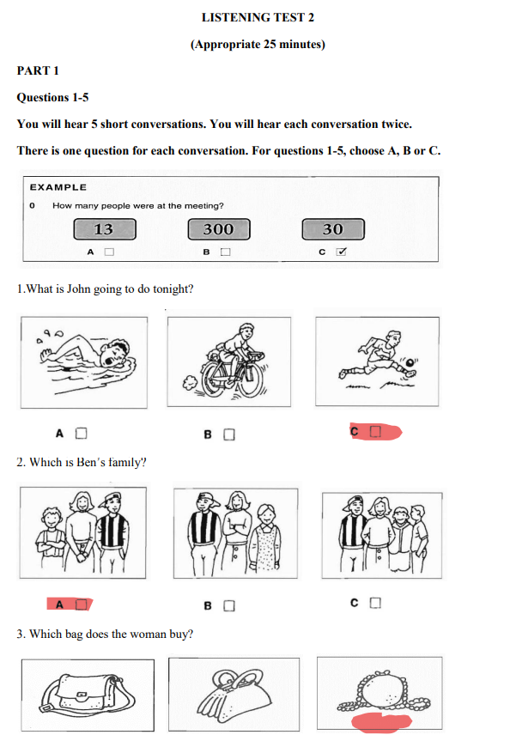
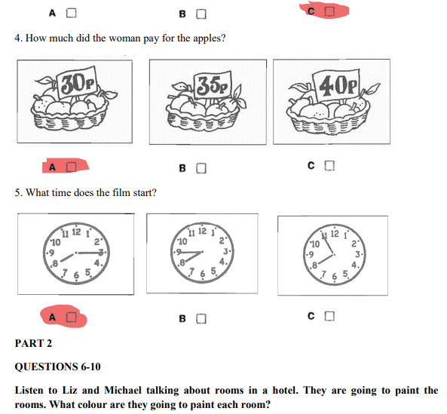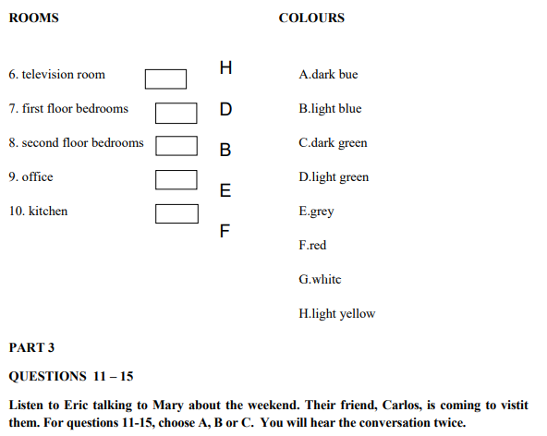

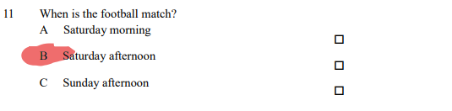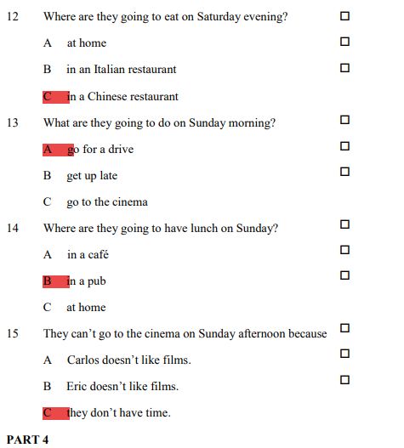
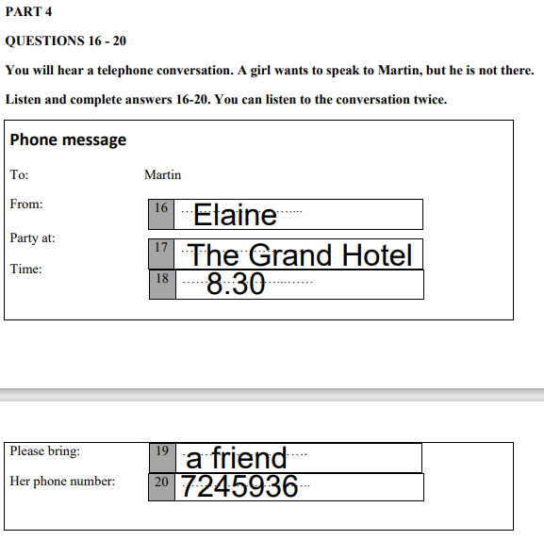

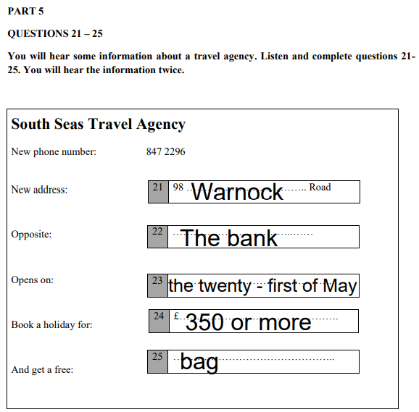

PART 1
QUESTION 1-5
Which notice (A-H) says this (1-5)?
For the questions 1-5, choose the correct option (A-H).
EXAMPLE ANSWER
0 This is broken. C
1 | Children pay less than adults here. H |  |  | SUMMER SALE  LOW PRICES IN ALL DEPARTMENTS  A  FIRE DOOR  KEEP CLOSED
2 | Be careful because this will burn. F |  |  | B  C | LIFT NOT WORKING
3 | We don’t want any money yet. E |  |  | D | TOY SHOP NOW OPEN  BUY NOW  PAY NEXT YEAR
4 | Things are cheaper here. A  Cheap=low price |  |  | E
5 | You must pay with cash. G |  |  | F | Keep this nightdress away from fire!
 | Cash, cheques, credit card
 |  |  |  | G | We do not take cheques or credit cards.
Under 12s
HALF PRICE

1. …H….. |  | 2. …F…….. | H  3. …E….. |  |  | 4. …A….. | 5. …G…..

PART 2
QUESTIONS 6 – 10
Read the sentences (6 to 10) about a swimming pool. Choose the best word (A, B or C) for each space.
6. Everyone must ........................... a shower before they go in the water.
A do B make C take
7. There are special changing rooms for .................... with young children.
A brothers B parents C cousins
8. Please .................... to take a towel with you to the pool.
A know B understand C remember
9. If you are ...................., you can get a drink in the snack bar upstairs.
A dirty B thirsty C wet
10. In the afternoons, there are swimming classes for children of all ..................... .
A ages B lessons C pupils
PART 3
QUESTIONS 11-15
Complete the five conversations. Choose the most appropriate response for your answer.

11 How far is it to Manchester? | A About two months.  B It’s quite long.  C Almost 30 kilometres.
12 Could you give me the butter? | A Here you are.  B Thank you.  C I don’t know.
13 John hates shopping. | A I love it.  B It’s six pounds.  C The shop’s open.
14 I’ve already done my homework. | A When did you do it?  B Please do it.  C Have you done it yet?
15 What’s the date today?  day | A It’s Thursday.  B The third, I think.  C I’m 22 today.

QUESTIONS 16-20
Complete the conversation. What does the tourist say to the shop assistant?
For questions 16-20, choose the most appropriate response (A-H) for your answer.

 | Assistant: For children or adults?  Tourist: 16 B  Assistant: A lot of tourists buy this one.  Tourist: 17 F  Assistant: What about this one with fewer pages?  Tourist: 18 H  Assistant: The hardback is £8, and the paperback is £3.50.  Tourist: 19 A  Assistant: Fine. Shall I put it in a bag for you?  Tourist: 20 E  Assistant: Here you are. Thank you. |  |  |  | A. I’ll take the cheaper one.  B. Oh, it’s for me. I want a guidebook.  C. I haven’t got any children.  D. Yes, please. I’d like a book about London.  E. No, thank you. I want to use it now.  F. That’s very heavy. Have you got a smaller one?  G. Is it a good book?  H. That looks better. How much is it?
16. …B… |  | 17. F…… | 18. …H…… | 19. …A…. |  | 20. …E…….

PART 4

QUESTIONS 21-27

Read the article about some birds. Are sentences 21-27 “Right” (A), “Wrong” (B), or “Doesn’t say” (C). Choose A, B or C for your answers.

2
1. Bill Lishman is a farmer.
A. Right | B. Wrong | C. Doesn’t say
22. Bill lives with his parents.
A. Right | B. Wrong | C. Doesn’t say
23. Bill carried the geese in his plane.
A. Right | B. Wrong | C. Doesn’t say
24. This was Bill’s first visit to Virginia.
A. Right | B. Wrong | C. Doesn’t say
25. Bill wanted the geese to stay at his home for the winter.
A. Right | B. Wrong | C. Doesn’t say
26. Bill stayed in Virginia all winter.
A. Right | B. Wrong | C. Doesn’t say
27. The geese returned to Canada in the spring.
A. Right | B. Wrong | C. Doesn’t say

PART 5
QUESTIONS 28-35
Read the article about air travel.
For questions 28-35, choose the best word for each space.

A HISTORY OF AIR TRAVEL
In 1783, two French brothers built (0) _______ first balloon to take people into the air. One hundred and twenty years later, in 1903, the Wright brothers built the first plane with an engine and (28)______ in it. This was (29)______ the United States. Then, in 1918, the US Post Office began the first airmail service.
Aeroplanes changed a (30)______ in the next thirty years. Then, in the 1950s, aeroplanes became much (31)______ because they had jet engines.
In 1976, Concorde was built in the UK and France. It is the fastest passenger plane in the world and it (32)______ fly at 2500 kilometres an hour, so the journey (33)______ London to New York is only four hours.
Today, millions of people travel (34)___ aeroplane, and it is difficult to think of a world without (35)______ .
Without/ at/ with + O/n/v-ing

EXAMPLE |  |  |  | ANSWER
0 | A. the | B. a | C. one | A

28. A. fly B. flown C. flew
29. A. in B. at C. through
30. A. lot B. many C. few
31. A. fast B. faster C. fastest
32. A. must B. should C. can
33. A. between B. from C. of
34. A. with B. on C. by
35. A. them B. their C. they

PART 6

QUESTIONS 36 – 40

Read the descriptions (36-40) of some holiday words. What is the word for each one?

Write the correct word in the box. The first letter is already there.
EXAMPLE  0. You may need this to leave the country. | ANSWER  p a s s p o r t
- People can swim or sail a boat here.  - Cars travel on this from one town to another.  - You have to open this to go into a farm or a garden  - A farmer can grow vegetables or keep animals in this  - These have wings and can sing and fly in the sky. | l ake  r oad  g ate  f ield  b irds

PART 7
QUESTIONS 41-50
Complete this letter with ONE word for each space (41-50). Type the correct word in each box (41-50).
Dear Sir,
I read your advertisement for English courses (41)............ the newspaper. I would (42) .......... to have some more information. How (43)....... does a course cost? Also, (44)......... long is each course and when does the next course start?
Yours,
Maria Gonzalez

Dear Ms. Gonzalez,
Thank (45)............ for your letter. Our next course starts in three weeks, (46) .......... Monday, 9 May. This is a six-week course and it (47)....... £150. If you prefer (48)......... begin in June, we have (49)............ ten-week course for £200. I hope (50)............ is the information you want.
Yours,
David May

41 in | 42. like | 43. much | 44. how | 45.you
46. on | 47. is/ costs | 48. to | 49. a | 50.this

PART 8
QUESTIONS 51-55
Read the advert and the email.
Fill in the information in Robert’s notes. Write your correct answer in each box (51-55).

ROBERT’S NOTES
Car racing
Steve’s phone number:  Date:  Cost of my ticket?  Place:  Leave Steve’s house at:  Travel there by: | 066554924
 | 51 | 7 August
 | 52 | £ 5
 | 53 | Napier Stadium
 | 54 | 8.30 a.m.
 | 55 | car

PART 9
QUESTION 56
You are Jack. Your friend Mike has asked you to go swimming tomorrow evening. You can’t go. Write a note to your friend.
Say:
- why you can’t go
- when and where you can meet your friend on another day.
Write 25-35 words.
Write your note on the answer sheet.

Hi Mike,
Thanks for your invitation. I am sorry for not going swimming with you tomorrow eveening because I have a English lesson. Would you like go to the coffee in this morning Saturday? Can we meet at 9 a.m?
I am looking forward to seeing you.
Love
Jack
NGHE
